Last Updated: March 2020

Explorer Version: USFS.2019.4

# OVERVIEW:

# LCMS Data Explorer

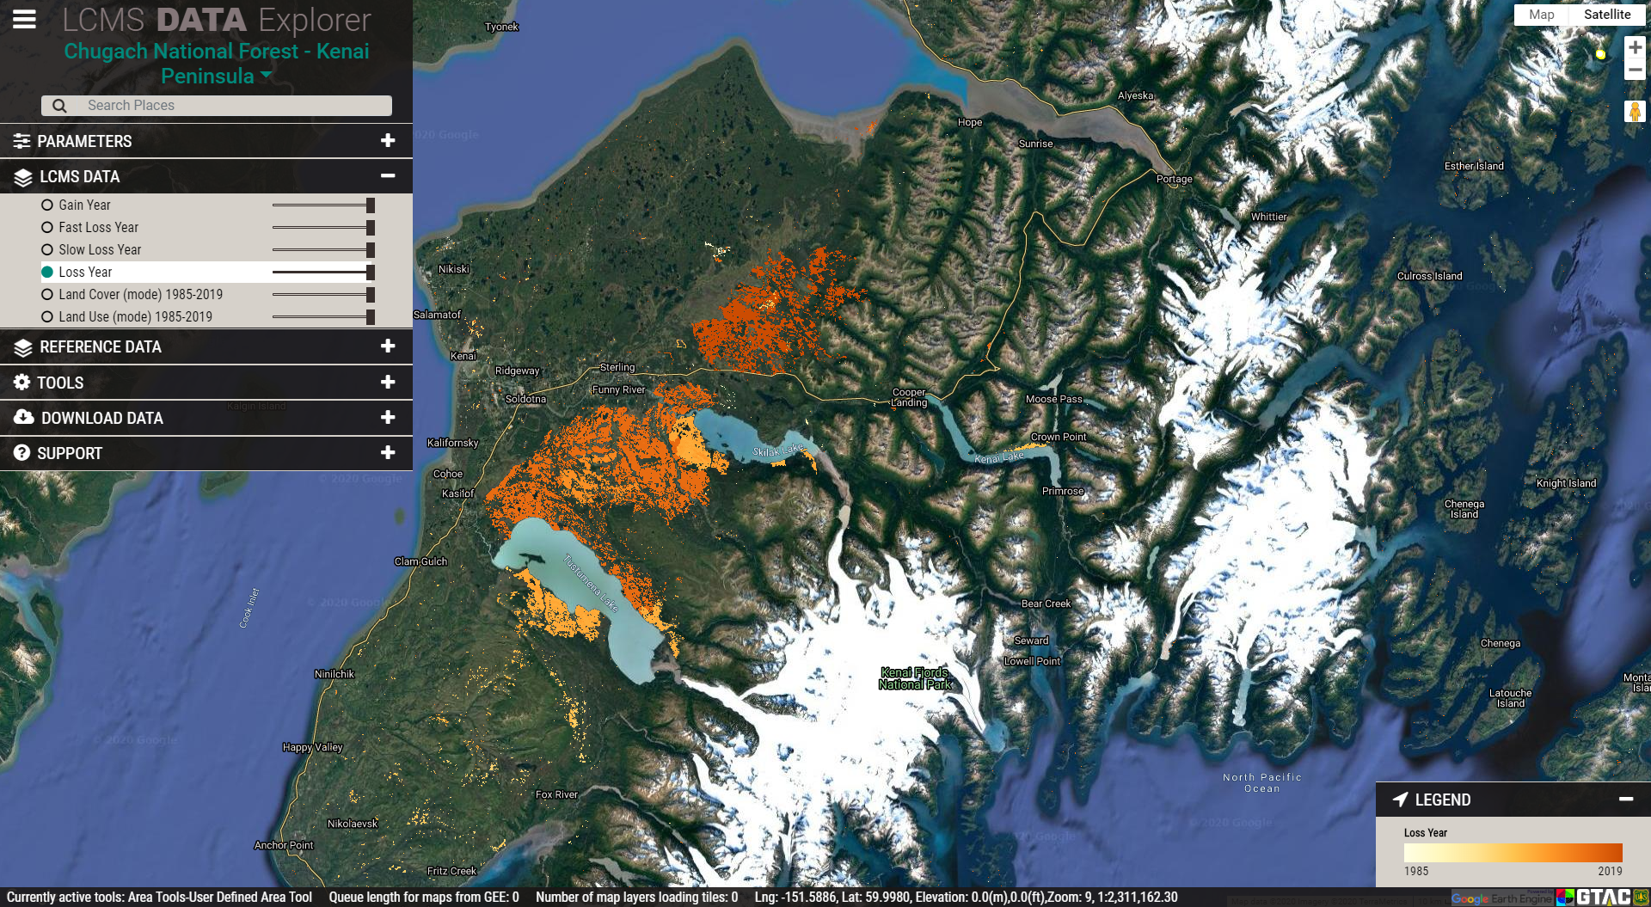

Introduction

This guide is designed to provide an overview for navigating and downloading data produced for the USDA Forest Service’s Landscape Change Monitoring System (LCMS) using the LCMS Data Explorer. The LCMS Data Explorer is the best tool for quickly viewing and downloading available data products.

The LCMS Data Explorer can be found at: <http://lcms.forestry.oregonstate.edu/>

Objectives

* Learn how to navigate the LCMS Data Explorer web application.
* Download data from the LCMS Data Explorer.

Required Software

* A web browser other than Microsoft Internet Explorer.

Prerequisites

* Basic understanding of how to use a simple GIS, such as Google Maps or Google Earth.

Contacts

* LCMS general inquires: [sm.fs.lcms@usda.gov](mailto:sm.fs.lcms@usda.gov) 801-975-3841

Table of Contents

Part 1: Navigating the LCMS Data Explorer 3

Part 2: Navigating Standard Mode 6

Part 3: Navigating in Advanced Mode 19

1. Navigating the LCMS Data Explorer

This section introduces the user to general navigation and functionality of the LCMS Data Explorer.

* 1. Explore the Google Tools



Launch the LCMS Data Explorer by [clicking this link](http://landscape-change-explorer.appspot.com/) (<http://lcms.forestry.oregonstate.edu/>). Begin by focusing on the tools along the right side of the browser window. These are the default tools within all web mapping applications using Google Maps.

* + 1. At the top right you can choose between **map** view and **satellite** view for your base layer.
       1. **Map** view has a checkbox drop-down option to turn terrain view on and off.
       2. **Satellite** view has a checkbox drop-down option to turn labels on and off.
    2. Below the full screen button are zoom tools for viewing the map at different scales.
       1. Zoom In and Out can also be accomplished using the scroll wheel on your mouse.
    3. The orange person icon allows you to drop into street view.



* + - 1. You can click and drag the person onto the map area. Any area that becomes highlighted in blue is available for you to drop the person to see surface level imagery in that area.
      2. To exit street view, click the Full Screen button in the upper right corner of the window. Next, click the left-pointing arrow that pops up in the upper left corner of the window to exit street view. Finally, press ESC to exit full screen.
  1. Viewer Information Ribbon & Legends
     1. For additional information on a tool or layer, hover the mouse over the name and additional text will appear (if available).
     2. Navigate to the ribbon of text along the bottom of the data viewer.



* + - 1. The info bar contains various bits of information pertaining to the viewer and the data
         1. **Currently active tools** tells the user which tools are turned on
         2. **Queue length for maps from GEE** tells the user how many data layers still need to load.
         3. **Number of map layers loading tiles**: How many of the enabled layers that are actively loading tiles.
         4. **Lat/Long, Elevation**: Coordinates of the mouse location
         5. **Zoom**: map view extent
    1. The legend, located on the bottom right of the viewer, will display info about LCMS and Reference Data layers that are turned on.

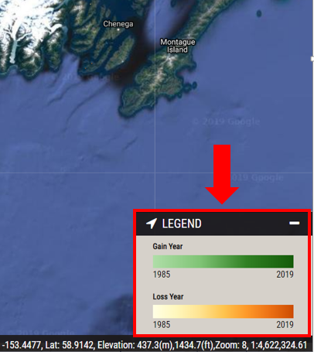

1. Navigating Standard Mode

This section reviews the menus and options available in the browser and the tools available in the Standard mode. These are the primary tools used to explore LCMS data and are the focus of this guide.

* 1. LCMS Region

You can change the LCMS region displayed by clicking the teal drop-down menu in the upper-left-hand corner of the data explorer.

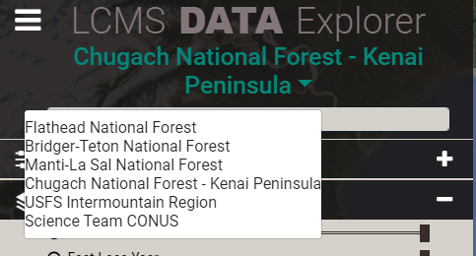

* 1. Parameters

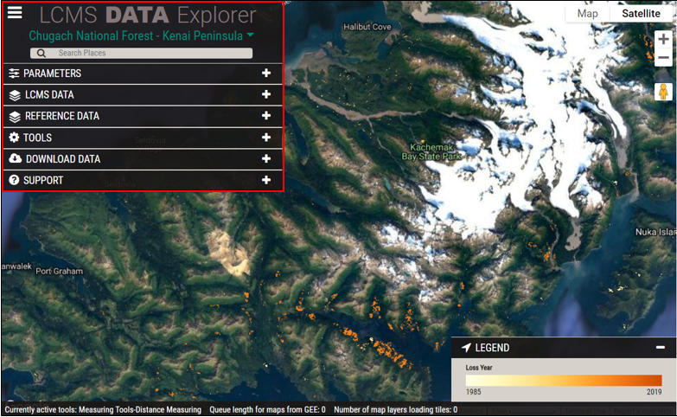

The menus and associated options are located along the left side of the browser window. To show the options under each heading, maximize it by clicking the “+” on the right side of the tab. When you’re ready to minimize it again, simply click the “-“.

* + 1. Begin by clicking the **Parameters** tab at the top of the list.
    2. Under **Choose which mode** select **Standard**.

***Note:*** *Advanced Mode will be explored in a later section of this document.*

* + 1. Leave the analysis years as “1985-2019” for now and click **Submit**.
       1. If the Submit button is blacked out, the selected options are already being processed.
  1. Explore the LCMS Data tab
     1. Click the **LCMS Data** tab located directly under the **Parameters** tab.

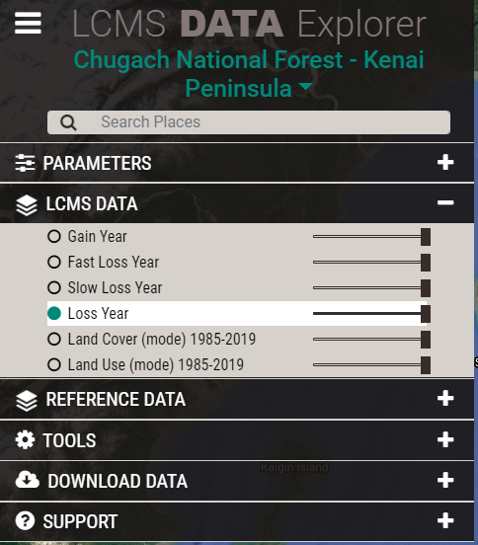

* + 1. Six layers are available to view in Standard Mode:
       1. Gain Year: most recent year of gain (1985-2019)
       2. Fast Loss Year: most recent year of fast loss (1985-2019)
       3. Slow Loss Year: most recent year of slow loss (1985-2019)
       4. Loss Year: most recent year of loss (1985-2019)
       5. Land Cover (mode): the most common land cover class (1985-2019)
       6. Land Use: most common land use class (1985-2019).
    2. Turn the layers on and off by clicking their corresponding radio button.
    3. Use the slider next to each layer to change the transparency in the viewer window. 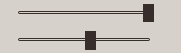
  1. Explore the Reference Data tab
     1. Next, click the **Reference Data** tab. These reference data sets provide additional geospatial information that may be useful for exploring the LCMS data and may vary depending on LCMS Region.

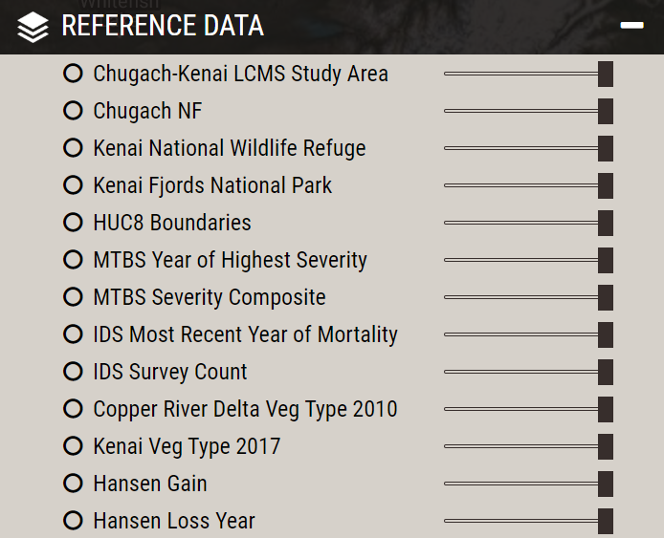

* + 1. This set of tools allows you to display information directly from the web map without downloading data.
    2. Use the sliders to change the transparency of layers on the display window

***Note:*** *You may see less information than in the graphic above depending on the study area you are viewing, which LCMS Layers are selected, and where you clicked on the map.*

* 1. Explore the Tools tab
     1. Click on the **Tools** tab

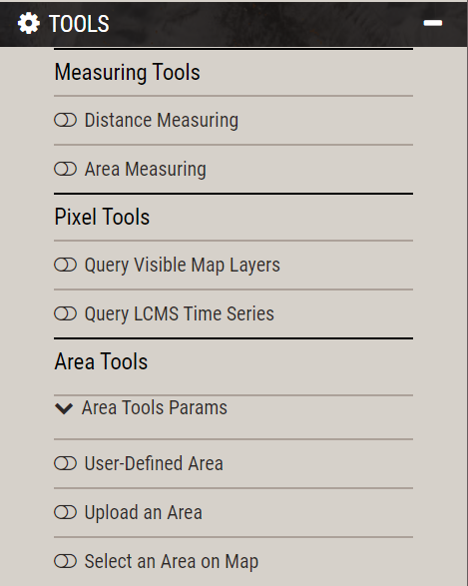

* + 1. There are three main tool types in Standard Mode: Measuring, Pixel, and Area. Each tool can be turned on by clicking the slider button located to the left of each tool



* + 1. **Measuring Tools:**
       1. Distance Measuring**:** Click anywhere to begin a linear measurement. The option buttons allow the user to undo, delete, and change the color of the measurement line. The user can also choose Imperial or Metric measuring units.

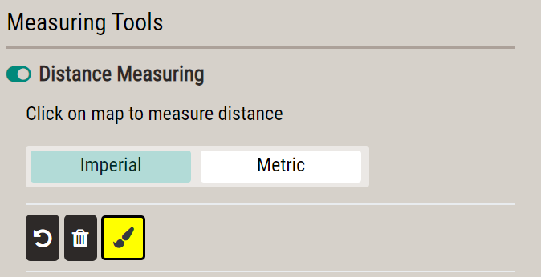

* + - 1. Area Measuring: Click anywhere to begin delineating an area on the map, **single click** to create a vertex, and **double click** to complete a polygon area. The option buttons allow the user to undo, delete, and change the color of the area boundary line. The user can also choose Imperial or Metric measuring units.

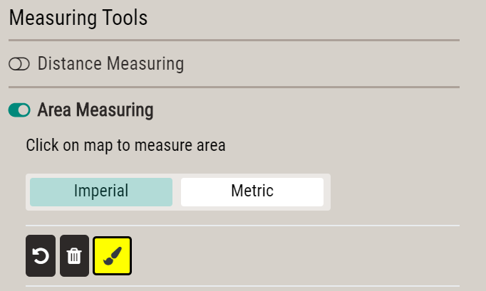

* + 1. **Pixel Tools:** 
       1. Query Visible Map Layers: 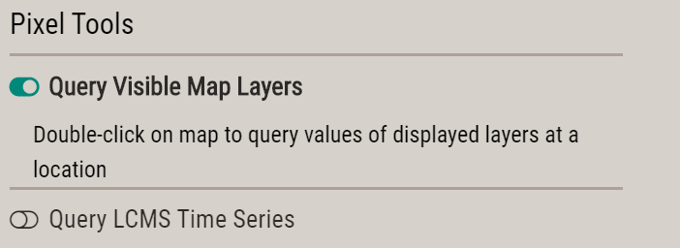
          1. Double-click a point of interest in the project boundary. A table will automatically pop up displaying the pixel values for visible LCMS or Reference data layers.
       2. Query LCMS Time Series:

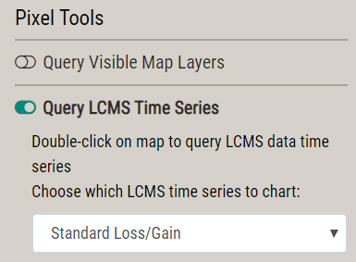

* + - * 1. Choose the layers that you would like to display in the time series chart by expanding the drop-down menu. Available options are:

Standard Loss / Gain:

Displays Loss Probability, Gain Probability, Normalized Burn Ratio (NBR) from Landsat satellite composites, and a smoothed NBR calculated with the LANDTREDR algorithm.

Advanced Loss / Gain:

Displays Loss Probability, Gain Probability, Fast Loss Probability, Slow Loss Probability, NBR, and smoothed LANDTRENDR NBR.

Advanced Loss / Gain and Land Cover / Land Use:

Displays Loss Probability, Gain Probability, Fast Loss Probability, Slow Loss Probability, Land Cover class, Land Use class, NBR, and smoothed LANDTRENDR NBR.

Land Cover Probability (Chugach National Forest – Kenai Peninsula and USFS Intermountain Region only):

Displays the probability of each land cover type.

* + - * 1. Double-click a point of interest in the project boundary. A chart will automatically pop up displaying LCMS product information for that point.
        2. You can turn layers off and on by clicking their legend entries below the chart.

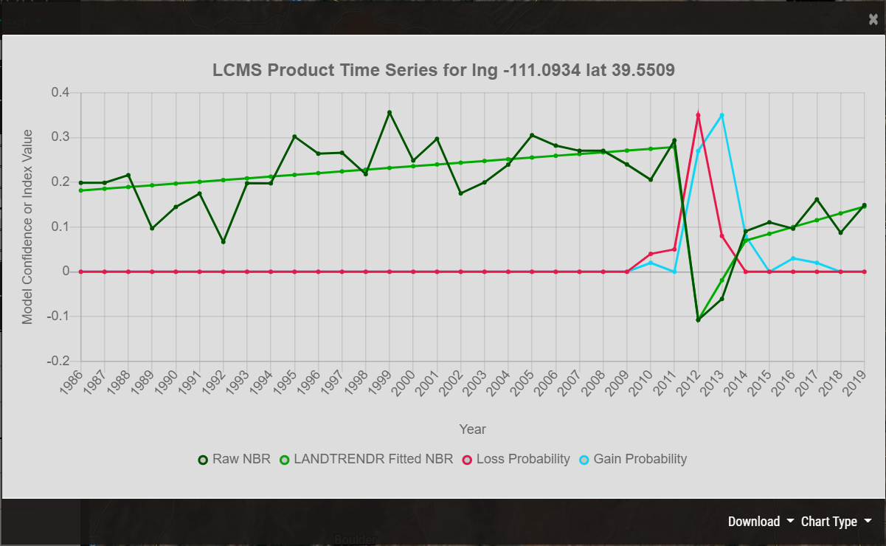

* + - * 1. Note the **Download** button at the bottom right of the chart. There is the option to download the chart as a CSV or PNG.
        2. There is also a **Chart Type** buttom at the bottom right of the chart. Here you can choose to view the data as a line or bar chart or as a table of values.
    1. **Area Tools:** 
       1. **User-Defined Area:** Allows the user to draw a polygon and obtain LCMS summaries for the area.
          1. Toggle on the User-Defined Area tool and type a name into the **Name your charting area** box, if desired.
          2. If desired, choose a color for the charting area by clicking the **paintbrush tool.** 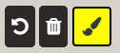
          3. **Outline** the area of interest by clicking to create vertices for a polygon. **Double-Click** to finish drawing the boundary. If another polygon is wanted, repeat this process. Then click **Chart Selected Areas**.

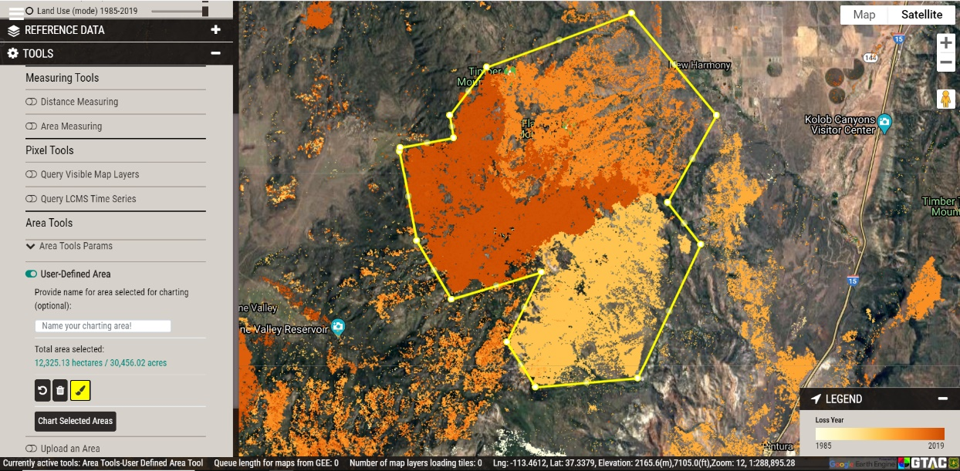

* + - * 1. 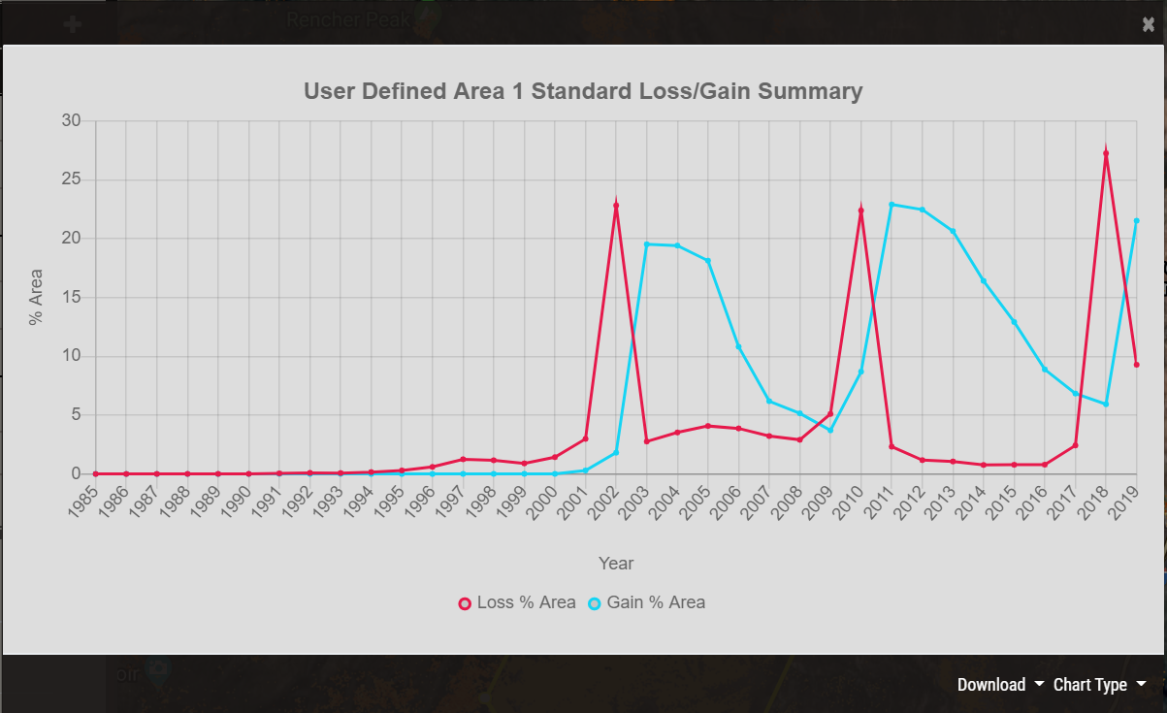A chart will automatically appear with a Loss/Gain summary: the percentage of the total area experiencing Loss or Gain during each year.
        2. Note the **Download** button at the bottom right of the chart. There is the option to download the chart as a CSV, PNG, or geoJSON (That icludes the user defined area).
        3. There is also a **Chart Type** buttom at the bottom right of the chart. Here you can choose to view the data as either a graph or a table of values.
        4. To delete this area of interest and draw a new one, click the **trash can icon** to delete the saved boundaries.



* + - 1. **Upload an Area:** The user can input a zipped shapefile (with all the necessary files) or geoJSON file of their choice. This will generate a Loss/Gain summary in the same fashion as step **5d** above.

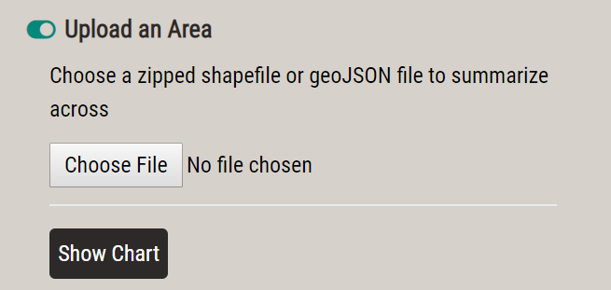

* + - * 1. Click **Choose File** to insert a user shapefile (zipped in a .zip file) or geoJSON you’re your computer and a chart with the information for the chosen area will generate. If the chosen file is too large (~ > 50 mb) the process will likely fail.
      1. **Select an Area:** The user can select from a list of pre-defined areas for which to generate the same summaries outlined above.
         1. 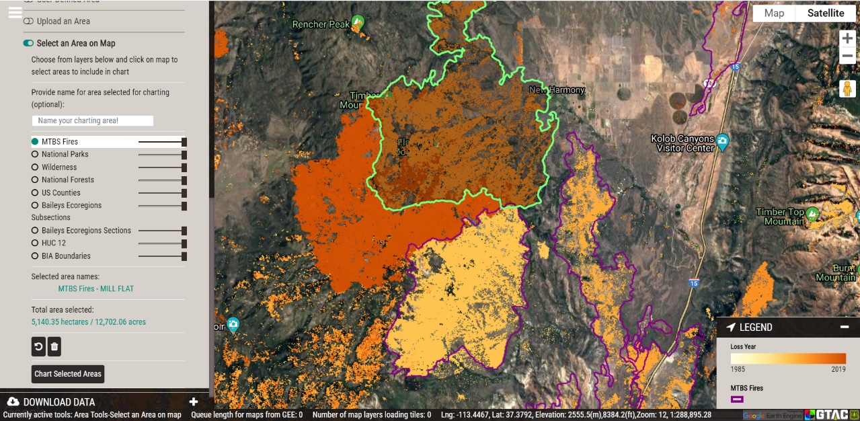Use the radio buttons next to the list of layers to turn on a layer to select the pre-determined boundaries from. Click on the polygons you would like to use for charting. It will draw the available areas of interest, and you can select one or more polygons by clicking them on the map. Click **Chart Selected Areas** to chart.
      2. **Area Tools Parameters:** The user can select which LCMS products to summarize in the chart by expanding the **Area Tools Params** dropdown menu, located just below the **Area Tools** heading.

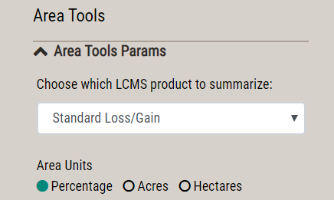

1. The LCMS product that is summarized can be changed with the dropdown.
2. The units that are used can be changed to portray proportions of the area or the actual area as acres or hectares.
   1. Download Data tab
      1. Click on the **Download Data** tab.
      2. From the **Select product to download** tab, choose the product you would like to download. Note that the availability of data varies from project to project.

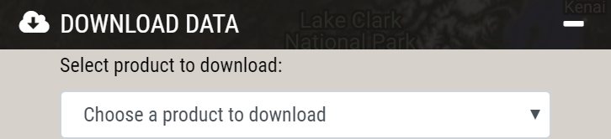

* 1. Support tab
     1. Information for contacting the LCMS team is available here.
     2. If the user has turned tool tips off, click **Show tool tips** to enable them. 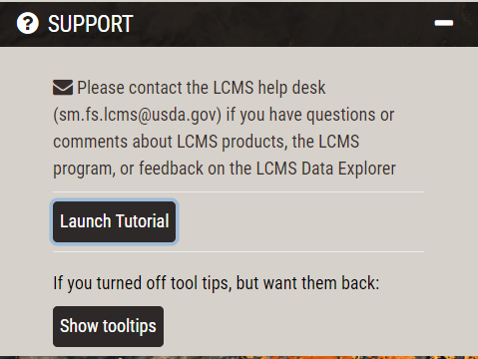

1. Navigating in Advanced Mode

This part introduces the user to the **Advanced** mode. Not all tabs within the interface will have advanced features. This part will highlight where to find these features, and it is recommended that the user reference part 1 and part 2 of this tutorial to become familiar with their location and implementation.

* 1. Selecting Advanced mode
     1. 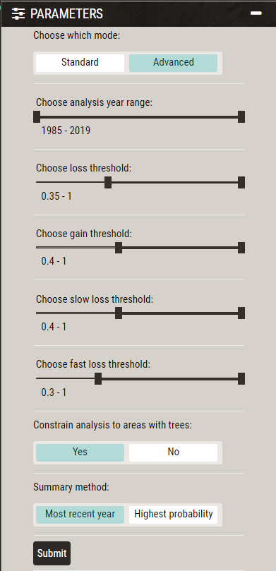Expand the **Parameters** tab and click **Advanced** under **Choose which mode**, then click **Submit:**
     2. A cascade of new options is now available.
        1. **Choose analysis year range:** The default selection is 1985-current, but if the user is only interested in a specific time frame, the slider can be adjusted.
        2. **Choose loss threshold**
        3. **Choose gain threshold**
        4. **Choose slow loss threshold**
        5. **Choose fast loss threshold**

**Note:** Loss and Gain are a proportion expressed as a decimal from 0.0-1.0. This value represents the proportion of classification trees within the Random Forest model ensemble that classified a pixel as loss or gain. If the value is 0.0, none of the individual classification trees classified the pixel as loss or gain. If the value is 0.5, half of the individual classification trees classified the pixel as loss or gain. If the value is 1.0 all the individual classification trees classified the pixel loss or gain. Loss and gain are modeled independently so any one location can have some level of loss or gain and can even express both within the same year. We set the default threshold to the value that maximizes the accuracy of the model, but this can be changed depending on the user’s needs.

* + - 1. **Constrain analysis to areas with trees:** Applies a mask to the Loss and Gain products so that Loss and Gain are only visible over pixels that have had a land cover classification of “Tree” (or “Tall Shrub” in Alaska) for at least 3 consecutive years out of the 35 possible years. This reduces noise over non-vegetated areas. Tree Mask “On” is the default setting.
      2. **Summary method:** Shows either the most recent year of change or the year with the highest probability of change in an area over the time series.
    1. Once the user has selected the desired settings, click **Submit.**

***Note:*** *this may take a moment to load, view the loading bar at the bottom of the screen for updates.*

* 1. Explore the LCMS Data Tab in Advanced Mode
     1. Expand the **LCMS Data** tab if it did not expand automatically.
     2. As before, hover over each layer name and some of them will have additional text that describes more about the layer.
     3. The legend(s) for selected layers will automatically be displayed on the right-hand side of the viewer.

**Congratulations!** You have successfully completed this exercise. You now know how to navigate the LCMS Data Explorer and download data for use within your own project.